Junit Test

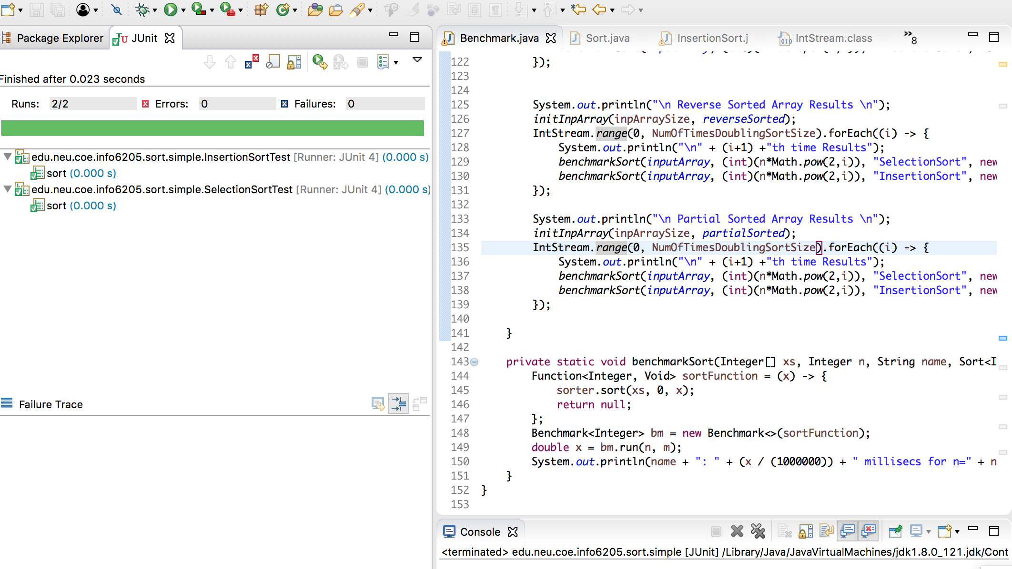

I have used warmup = 50, so that we better result for the average time.

Output:

Number of repetitions (m): 50

 Random Array Results

1th time Results

SelectionSort: 0.00710964 millisecs for n=10

InsertionSort: 0.00338474 millisecs for n=10

2th time Results

SelectionSort: 0.00645404 millisecs for n=20

InsertionSort: 0.0059481000000000004 millisecs for n=20

3th time Results

SelectionSort: 0.0108788 millisecs for n=40

InsertionSort: 0.03365804 millisecs for n=40

4th time Results

SelectionSort: 0.07900636 millisecs for n=80

InsertionSort: 0.06773528 millisecs for n=80

5th time Results

SelectionSort: 0.02613762 millisecs for n=160

InsertionSort: 0.06593386 millisecs for n=160

Sorted Array Results

1th time Results

SelectionSort: 3.3133999999999995E-4 millisecs for n=10

InsertionSort: 7.72E-5 millisecs for n=10

2th time Results

SelectionSort: 5.1272E-4 millisecs for n=20

InsertionSort: 1.6828E-4 millisecs for n=20

3th time Results

SelectionSort: 0.0018157 millisecs for n=40

InsertionSort: 1.656E-4 millisecs for n=40

4th time Results

SelectionSort: 0.0063765 millisecs for n=80

InsertionSort: 2.686E-4 millisecs for n=80

5th time Results

SelectionSort: 0.02241638 millisecs for n=160

InsertionSort: 4.7694E-4 millisecs for n=160

Reverse Sorted Array Results

1th time Results

SelectionSort: 1.763E-4 millisecs for n=10

InsertionSort: 5.0556E-4 millisecs for n=10

2th time Results

SelectionSort: 4.8066000000000005E-4 millisecs for n=20

InsertionSort: 0.00108406 millisecs for n=20

3th time Results

SelectionSort: 0.0016953 millisecs for n=40

InsertionSort: 0.00419724 millisecs for n=40

4th time Results

SelectionSort: 0.006790180000000001 millisecs for n=80

InsertionSort: 0.04229414 millisecs for n=80

5th time Results

SelectionSort: 0.02789364 millisecs for n=160

InsertionSort: 0.06208886 millisecs for n=160

Partial Sorted Array Results

partially Sorted from: 133 to:293

1th time Results

SelectionSort: 2.9492E-4 millisecs for n=10

InsertionSort: 1.8536E-4 millisecs for n=10

2th time Results

SelectionSort: 8.939400000000001E-4 millisecs for n=20

InsertionSort: 9.3008E-4 millisecs for n=20

3th time Results

SelectionSort: 0.0030496399999999997 millisecs for n=40

InsertionSort: 0.0045383 millisecs for n=40

4th time Results

SelectionSort: 0.006657560000000001 millisecs for n=80

InsertionSort: 0.007868 millisecs for n=80

5th time Results

SelectionSort: 0.02657344 millisecs for n=160

InsertionSort: 0.041086620000000004 millisecs for n=160